Log in http://www.calpassplus.org/LaunchBoard/guidedpathways.aspx
– Note: you will need a Cal-PASS Plus password
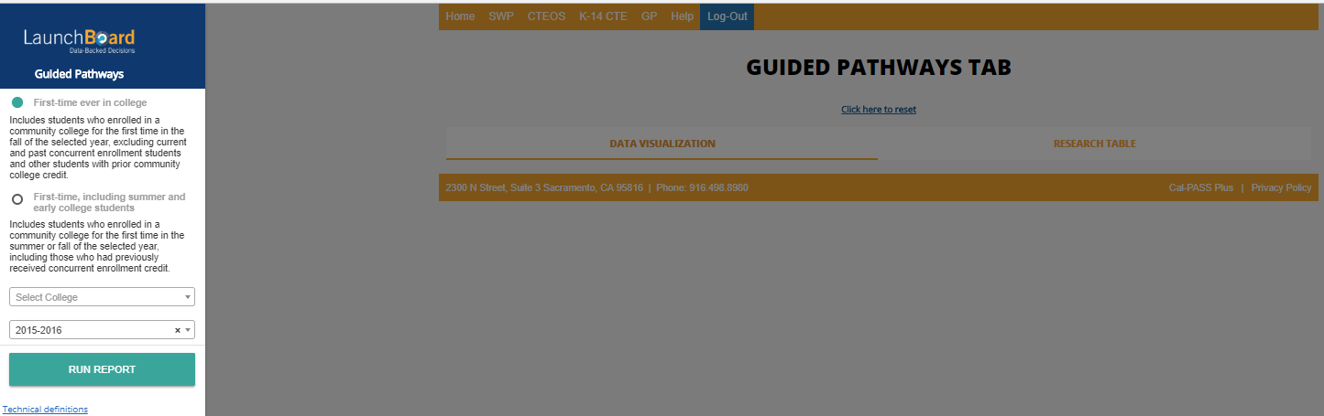
Select College
Select Cohort

Select your college and the cohort you want to look at. There are two cohorts. One includes your dual enrolled and other students the other eliminates these students from the results. If you have any summer starts or large dual enrollment you will want to pick the inclusive cohort. You can compare the effectiveness of summer strategies and dual enrollment by comparing results with the other cohort.
This is the statewide data for the cohort without summer and dual enrollment.
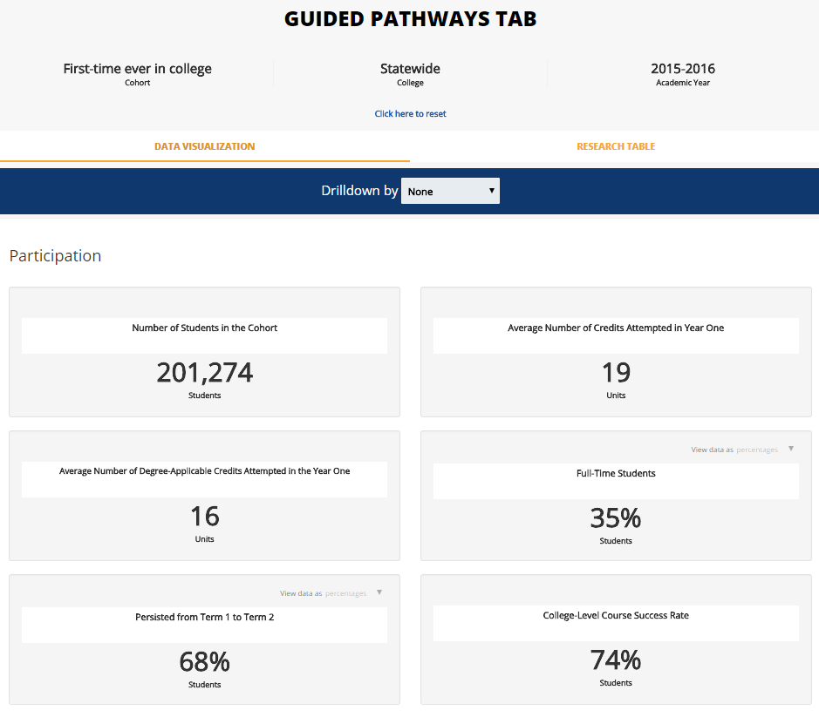

This is the statewide data for the cohort INCLUDING summer and dual enrollment. An increase of 53% more students
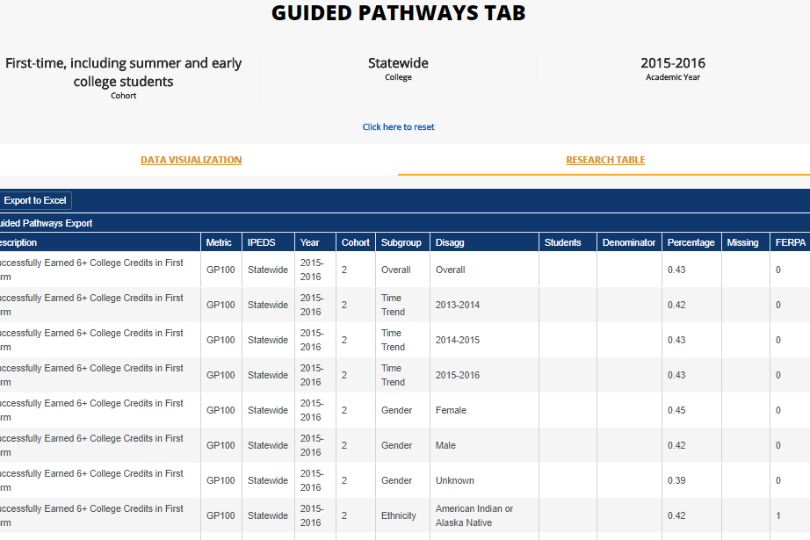
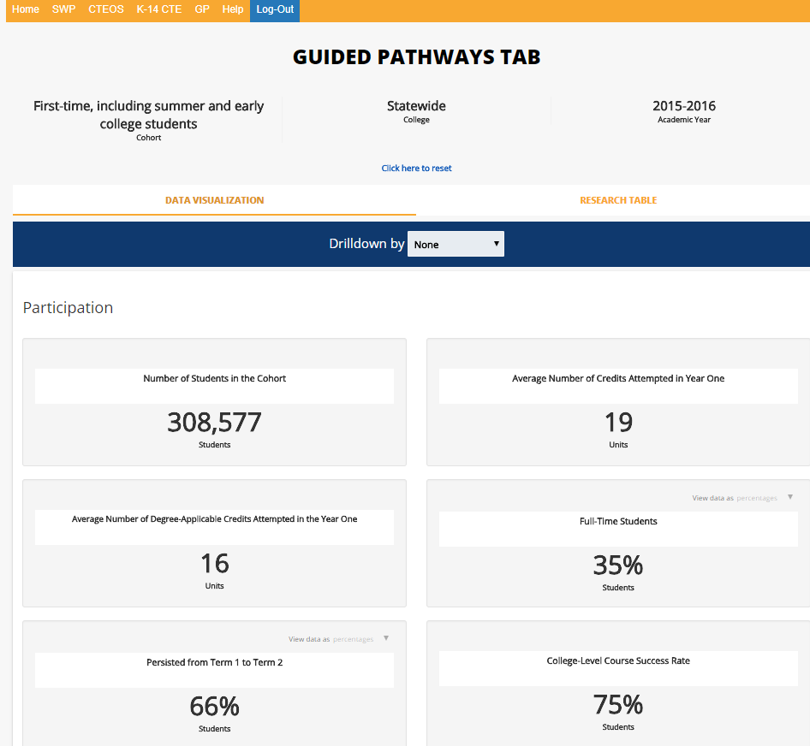

Scroll down to see the KPIs.
Click on the tab to get the research table

