The ASCCC Guided Pathways Task Force created a survey to identify specific information and tools to support academic senates through the design and implementation of a guided pathways framework.
Executive Summary
Rich data were collected from a survey sent to local academic senate presidents Spring 2018 about college engagement with guided pathways (GP). Overall, the data clearly show that colleges are engaged and faculty in most colleges are either leading or collaboratively guiding the work. There is still confusion about the various guided pathways programs, including the actual work of guided pathways such as how it is different from CTE pathways and first year experience. The survey clearly indicated areas of challenge and places that ASCCC can help the colleges in their implementation process. A list of benefits and potential negative outcomes provide great opportunity for training and resources to help colleges move in a positive direction. The need for models from other colleges, requests for clarity on verbiage and specific strategies indicated potential for regional visits, online resources and webinars. Numerous comments about addressing a collaborative and institution-wide vision indicate the importance of local communication and decision-making.
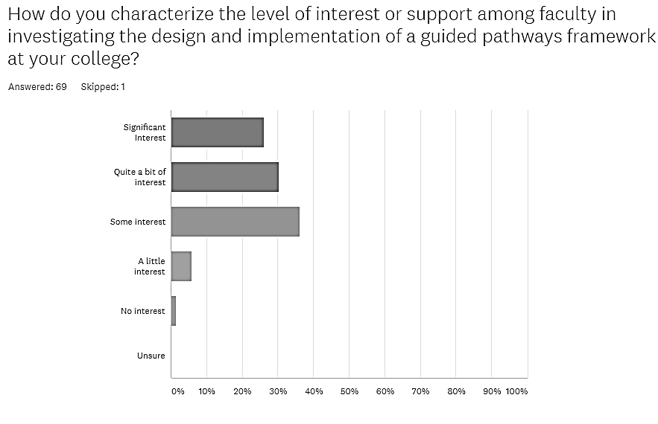
- There were 87 responses from 70 different colleges (61% of CCC’s) from validated faculty sources and with a broad representation of small and large, rural and urban, multi-college and single college districts, and all regions.

- 62% of responding colleges have a Guided Pathways Liaison

- Faculty interest was overwhelming with 98.6% responding that there was “significant, quite a bit or some interest”

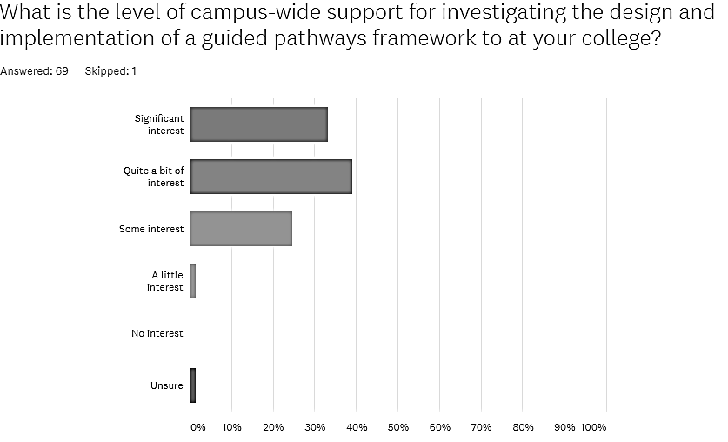
- 68.9% of respondents felt the process was faculty driven and although 90% indicated adequate faculty voice, numerous narrative comments indicated administration-related issues. Others indicated rocky starts, but improvement.

- Campus-wide interest in implementing a guided pathways framework was also reported as high at 97% (72% reporting quite a bit and strong interest).

- Most colleges (73.5%) reported adequate data resources but indicated a need to access and interpret data related to guided pathways.

- Comments indicated resources were hard to find. Requests for examples of practices were widespread, particularly for pathways mapping, meta-majors, implementation team startup, scheduling (enrollment management), data literacy, early alert, acceleration, multiple measures, communication plans, equity, onboarding, and retention strategies.

Potential Positive or Negative impacts from a Guided Pathways Framework Question 12

Best quote from this question “Change is hard…”
Potential Positive Effects | Potential Negative Effects
Potential Positive Effects on Institutions | Potential Negative Effects on Institutions
GP Framework allows student-oriented transformation | May fail to integrate important projects and initiatives
Great conversations; requiring greater and effective communication | Conflicts requiring mediation and compromise
Greater transparency and clarity | Fiercely guarded territory = tensions
Better faculty become mentors concerning jobs and transfer clarity on GE may be more fruitful for students and faculty | Loss of faculty autonomy; increased faculty competition for courses
Increase completions & decrease unnecessary units; Address completion and success rates | Performance –based goals may narrow student success focus
Profoundly transformational | Dysfunctional college no agreement on plan
Institution-wide collaboration; constant and deliberate collaboration | Marginalizing smaller departments without adequate representation
Potential Benefits to Students | Potential Negative Effects on Students
Closes equity gaps | Treating students as a number
Increased retention and persistence | Eliminate exploration; Destroying personal enrichment/liberal arts
Clear navigation for students | Loss of specific courses as evidenced by AB 705
Students better informed | Lack of choice; limit student autonomy
Alleviate students taking wrong courses and getting lost | Continuous nudging and alerts will irritate students like lifelong learners or self-motivated
Potential Benefits on Curriculum & Programs | Potential Negative Effect on Curriculum & Programs
Strengthen curriculum and programs (including currency, rigor and outcomes) | Reduced rigor to produce degrees education; Decrease development of new programs and courses
More career-focused curriculum | Effort to make student choose a major is additional work primarily placed on faculty
Academic goals will be achieved more quickly | Math and English sequences will impact overall curriculum
Potential Benefit for Student Services | Potential Negative Effect for Student Services
Better, more efficient, timely student services and access to services | Additional institutional barriers
Increased collaboration streamlining services | Students must pick career goals or majors too early
More resources shifted to student services | Funding models may negatively impact work
The entire survey summary, with helpful input from the colleges, is posted at the Guided Pathways Taskforce website at ASCCC under resources https://asccc.org/directory/guided-pathways-task-force

