Scenario 1 College Level Basics: CSUs expect students to complete the Golden Four GE courses within their first year, as they are considered “basic skills” or pre-requisites for college level coursework in other fields. The GE Breadth requirements (for CSU) in areas A1: Oral Communication, A2: Composition, A3: Critical Thinking, and B4: Quantitative Reasoning. In addition, early completion of these areas is associated with greater course success and program completion. As one college reviewed the scheduling for these courses they found that annually (fall, spring, summer as well as face-to-face, hybrid and online) they offered about:
- 160 total sections (approximately 6,400 seats) of 3 different courses satisfying area A1 Oral Communication (all in one department)
- 500 total sections of English 1A, (approximately 12,000 seats) the only course satisfying area A2 Composition
- 80 total sections of 5 different critical thinking courses, (approximately 2,400 seats) satisfying area A3 Critical Thinking (in 4 departments)
- 220 sections of 7 different courses, (approximately 6,600 seats) satisfying Area B4 QR and Math
Or display as a table
GE Area | Number of courses | Number of departments | Sections annually | Number of Seats
A1 Oral Communication | 3 courses  Public Speaking  Persuasive Communication  Small Group Communication | 1 department  Communication | 160 | 6,400
Area A2 Written Communication | 1 course  English Composition | 1 department  English | 500 | 12,000
Area A3 Critical Thinking | 5 courses  Introduction to Ethics  Critical Reasoning in History  Advanced Composition and Critical Thinking  Advanced Argumentation and Critical Thinking | 4 departments  Philosophy  History  English  Communication | 80 | 2,400
Area B4 Quantitative Reasoning and Mathematics | 7 courses  Elementary Statistics for Behavioral Sciences  Business Statistics  Pre-calculus  Calculus  Statistics  Liberal Arts Mathematics  Math for Elementary Teachers | 4 departments  Sociology  Business  Math  Education | 220 | 6,600
Questions to consider:
What are the limiting factors in students completing all golden 4 in one year? (success, seats, access, delivery method, time and location available, etc)
How might this influence program completion?
How does this complement the Guided Pathway milestones and Student Centered Funding Formula metrics?
How might scheduling with these factors in mind require different conversations than previously?
How might program mapping allow you to leverage the scheduling associated with area B4?

Scenario 2 Connections beyond the Discipline: Guided Pathways, Metamajors and Program Maps have begun to make colleges reconsider planning and scheduling processes. Whereas many schedules are developed by departments and then aggregated up to the whole college, this process assumes an institutional, not a student-focused perspective. Students need to complete their entire program package beyond major requirements to across disciplines including pre-requisite and support courses, as well as capstone, work study and internships. This may mean that within a department there is a split in the scheduling. Below are a couple examples:
In Biology the highly impacted courses often actually “feed” very different programs or metamajors – Anatomy and Physiology are not transferable for Biology majors so the pathway is aligned to allied health, health sciences and kinesiology.
As colleges have discussed where economics might fall in metamajors has identified a difference micro- and macro-economics align with pathways such as math, or political science or general economics.
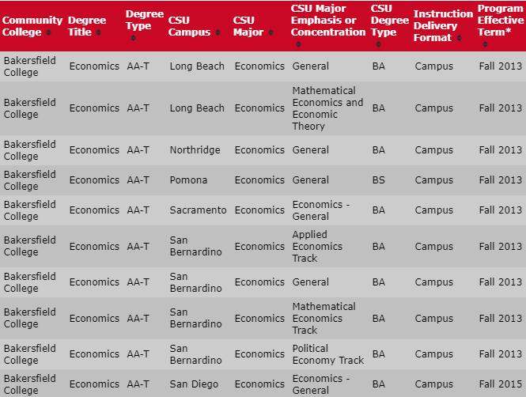
This is true in many disciplines. How would coordinating with major transfer pathways influence the suggestion for general education courses? How would this potentially impact scheduling?
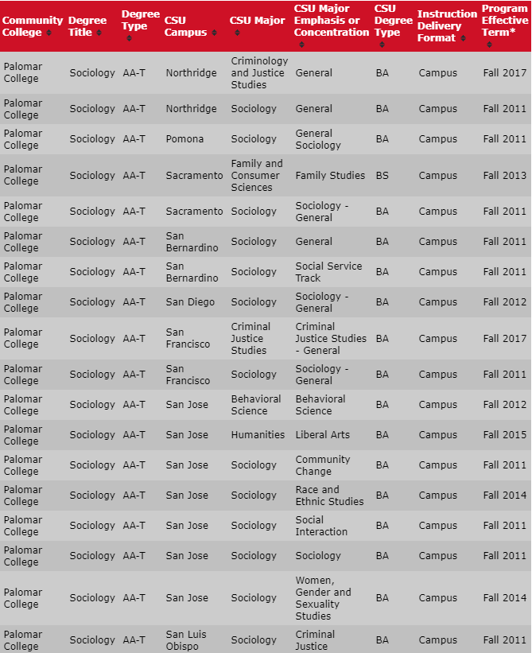

Scenario 3 Scheduling by Program and Unintended Consequences: One college decided to expand its Inmate course offerings based upon guided pathways. The appropriate programs based upon the most common majors selected were built into schedules that allowed inmates to complete transfer degrees. Spring 2019 saw an unduplicated headcount of 830 inmate scholars with 2,459 enrollments. The courses are scheduled in blocks allowing program completion with a two year or three-year pattern on 6 prison blocks (which relate to individual sites). The college average for degree completion is 7-8 years. As of May 2019, the program has graduated approximately 60 ADTs each aligning with four-year transfer institutions for parolees and continuing course offerings within the prison facilities. The college team has incorporated student ed planning and overcome the barriers of no technology, even implementing OER options for nearly half the sections. They just received notice that the program needs to cut 30 sections for the upcoming fall semester even though the sections are all waitlisted and no on-campus programs have been asked to cut sections.
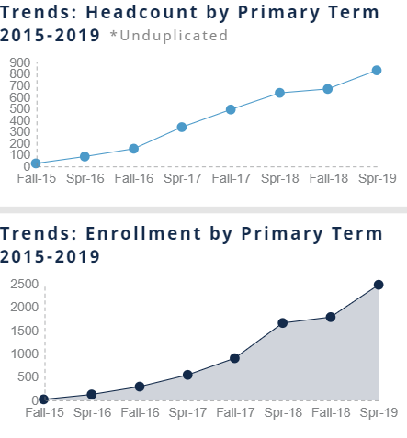
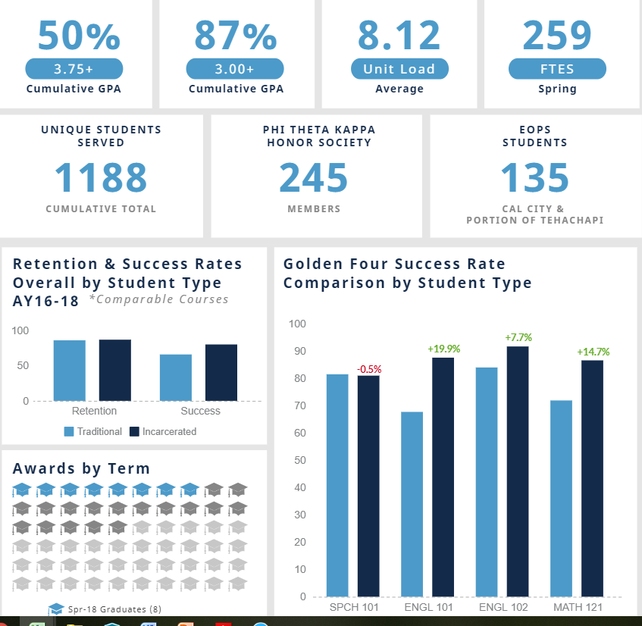
Consider the implications of this program with regards to the Student Centered Funding Formula (SCFF)?
Look at the student success data and consider the potential affects from both success and ethnicity ?
What are the implications of cancelling sections that may differ from regular scheduling of courses?
What are the complications of this program scheduling at 6 different sites?

Other ideas…

