Many Guided Pathways Institutions have reorganized and clustered areas that are similar based on a variety of factors, but always with a goal to making the choices clearer and more accessible to students. The ASCCC has developed a tool to help colleges determine their own Guidelines and Priorities in this reorganization process. Creating metamajors does not make a college a guided Pathways Institution. Jumping into the process without a reason and strategy can create undesired consequences. In coordination with the metamajors guidelines questions this is a warm up exercise when considering clustering or reorganizing your programs.

How and where does your college organize and communicate degrees and certificates?
List all of the areas a student would find this information.

Do students find this organization useful? How do you know?
Important Notes:
There is no magic number of metamajors or clusters
There are no standard names
There must be curriculum clean up first (ASCCC has identified many issues within curriculum data)
The college should create guidelines, particularly with the role of CTE and Exploration – Undeclared
There is significance in asking are these historical programs the right programs for our student population?
Districts should discuss, particularly from a student viewpoint and swirling; but no district-wide standardized clusters
There are a few standard names (not always) STEM, Allied Health, Business
There are few standard problems (Biology versus allied health, micro- versus macro-economics, communication, computer science)
Some areas have pre-requisites not within the award curriculum (allied health)
Many CTE areas do not appear to overlap due to focus
Combining CTE to one area may limit upward educational opportunities
Some areas want to be in multiple clusters, others want their own
Some want an exploration cluster others DO NOT
There are a few missing areas/clusters in CCC’s – Education, Global Affairs

Colleges have called the clusters and reorganization a variety of named. Examples:
Metamajors (MetaMajor, Meta-major) |  | Divisions
Focus Groups |  | Major Pathway
Career Pathways |  | Focus Areas
Areas of Interest |  | Clusters
Career and academic Pathways |  | Career + Academic Communities
Learning and Career Pathways |  | Career Fields and Clusters
Pathways |  | Fields of Study

Lake Tahoe Community College - Metamajors
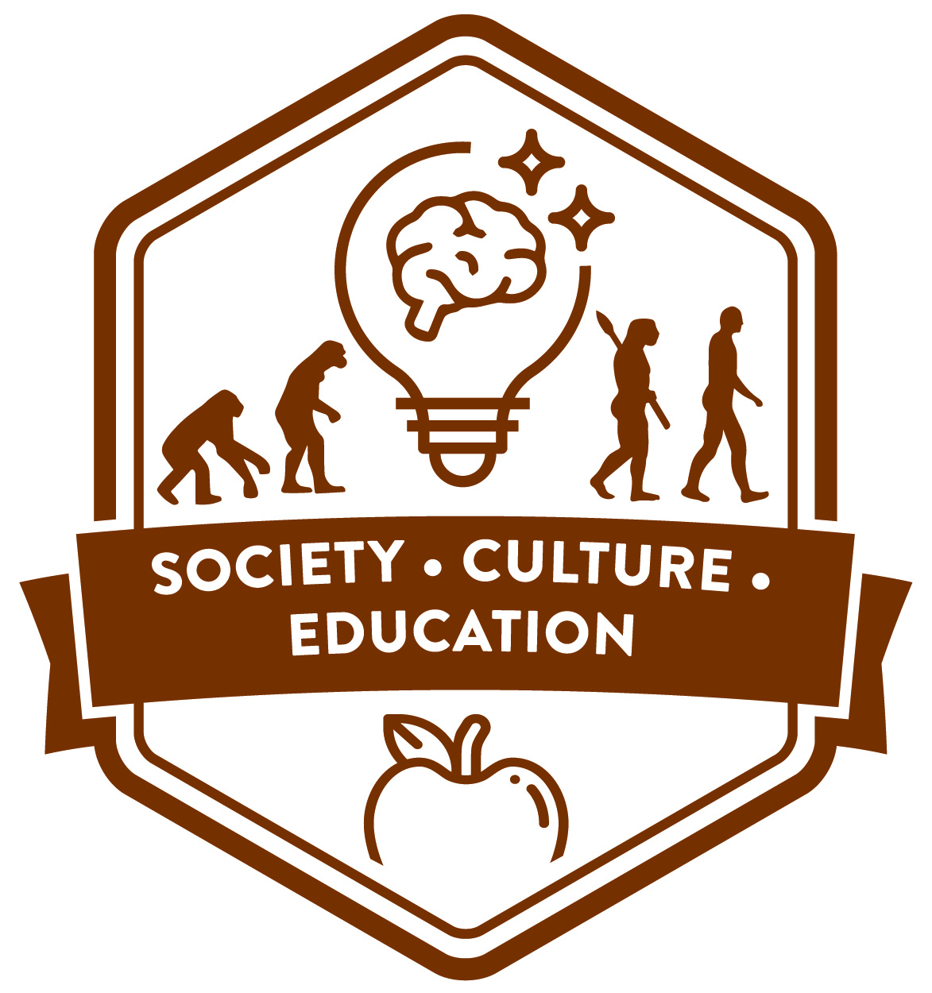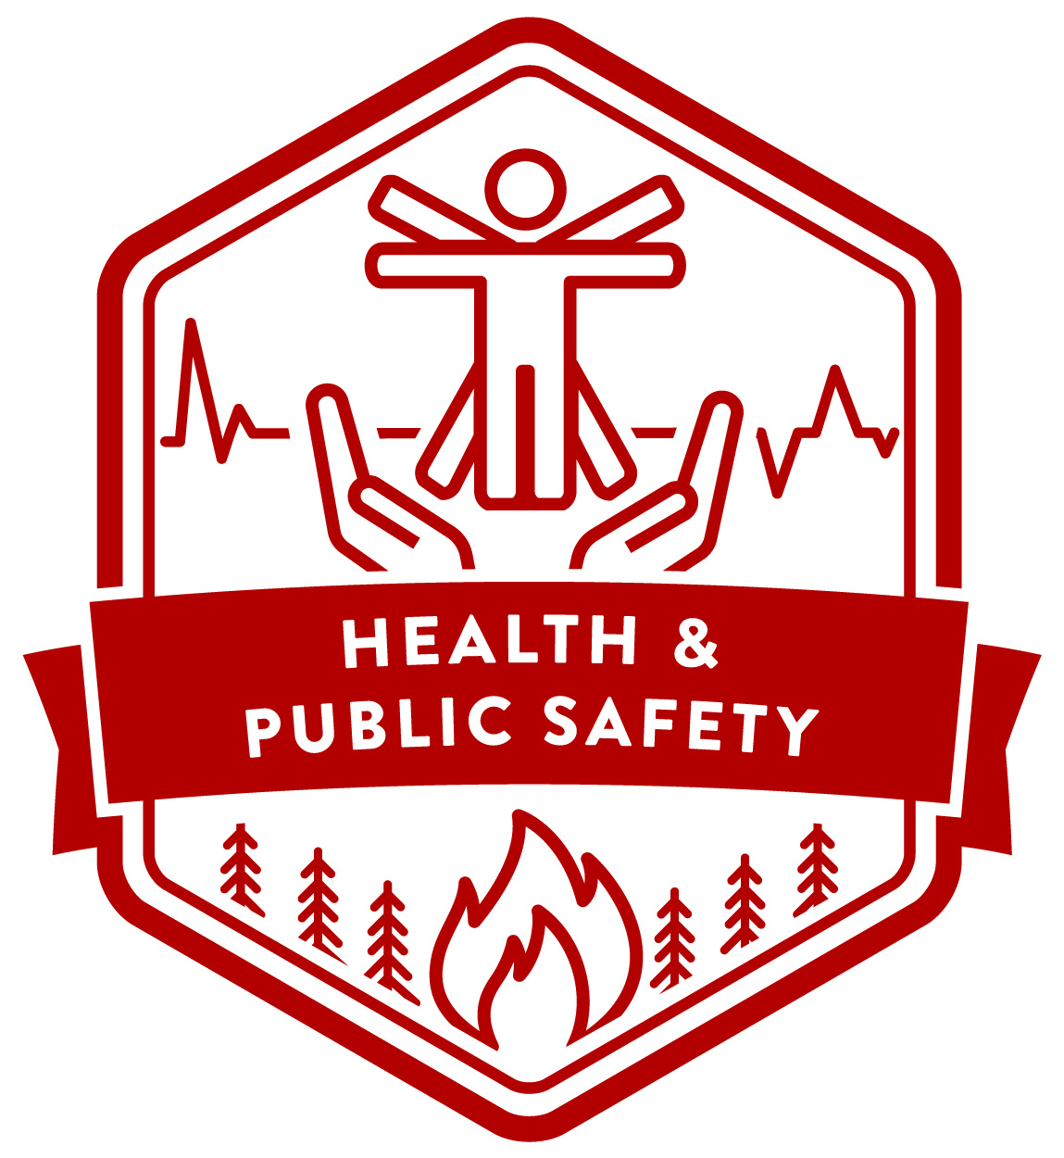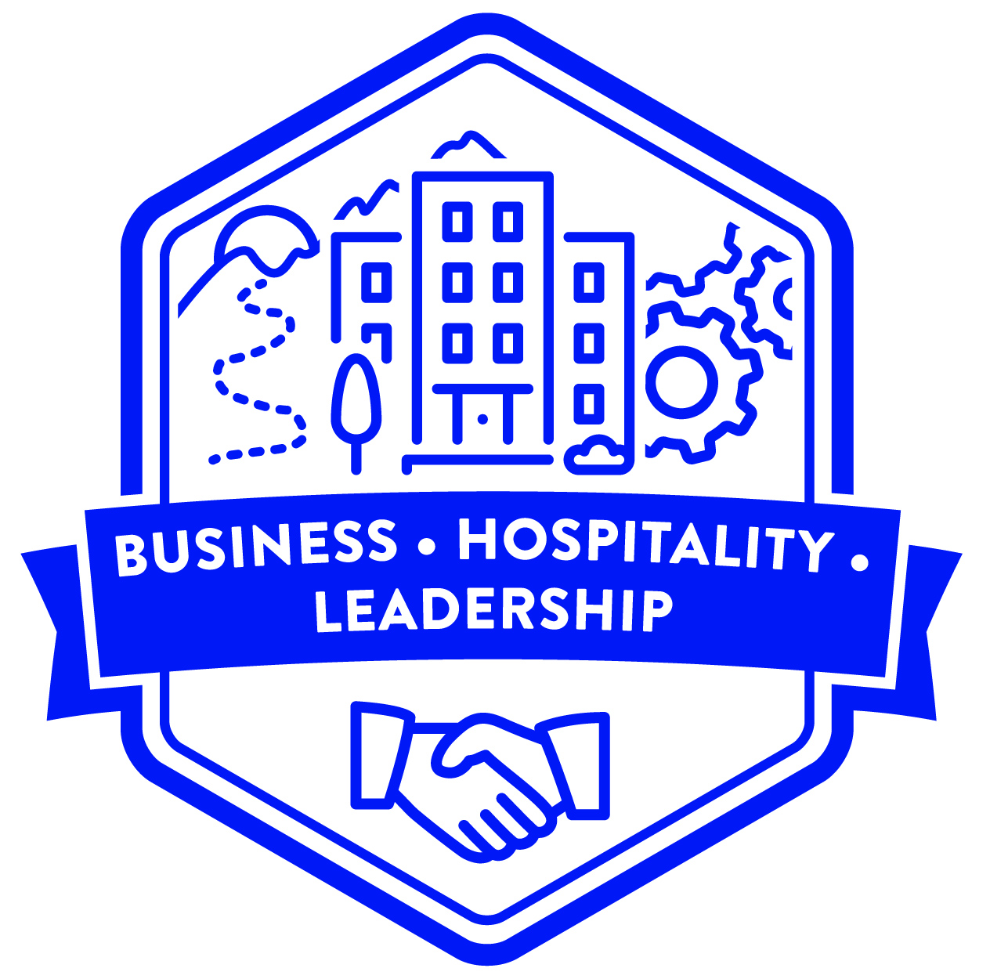**
Orange Coast College- Clusters for Focus Groups
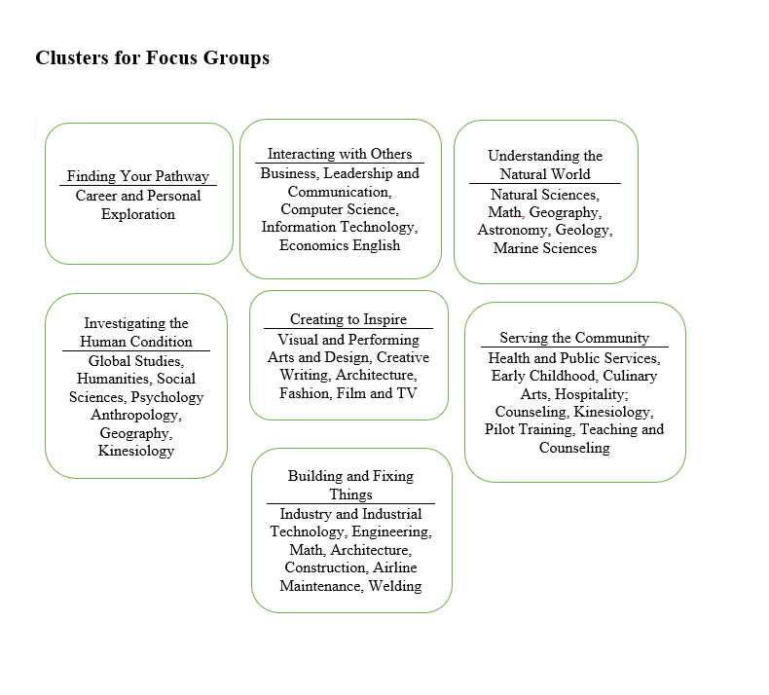
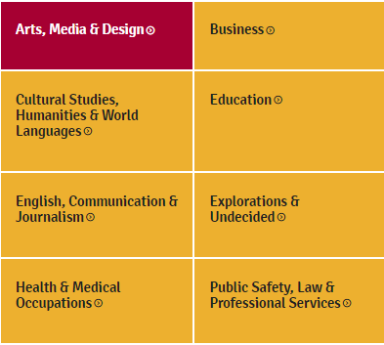
Southwest – Fields of Study https://www.swccd.edu/programs-and-academics/index.aspx

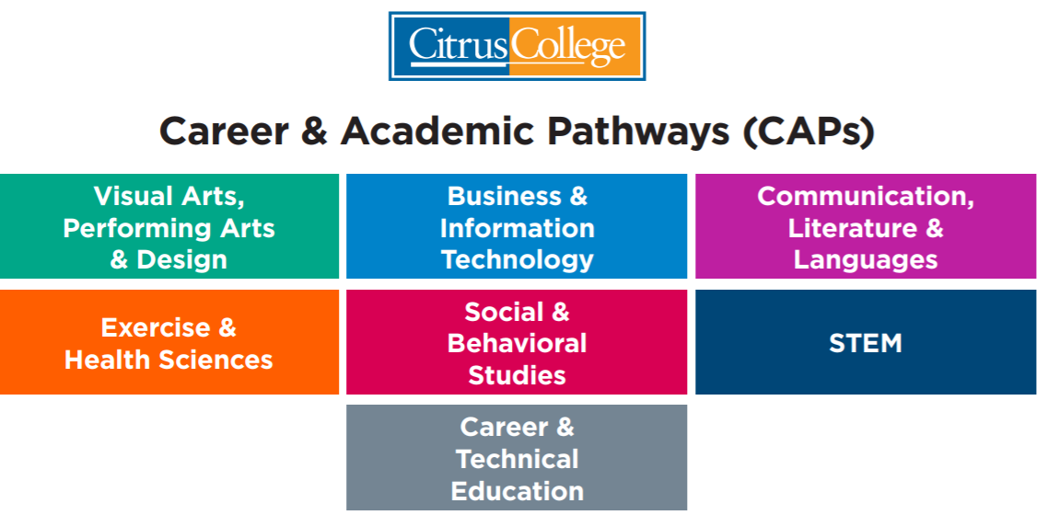
http://www.citruscollege.edu/guidedpathways/Pages/CAPs.aspx

Skyline College Meta Majors https://skylinecollege.edu/metamajors/

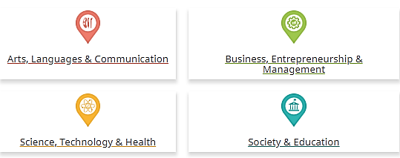

Bakersfield College – Learning and Career Pathways https://www.bakersfieldcollege.edu/academics/pathways
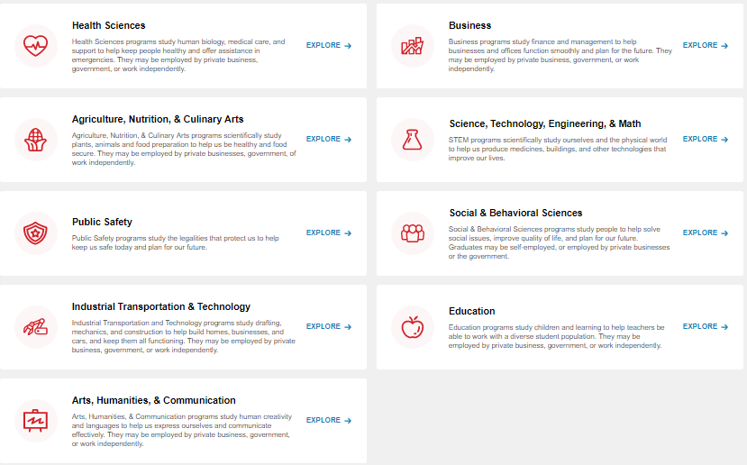

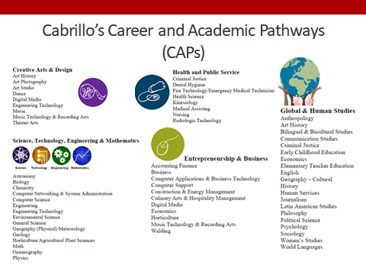

Odessa College- MetaMajors Wharton Junior College - Major Pathways
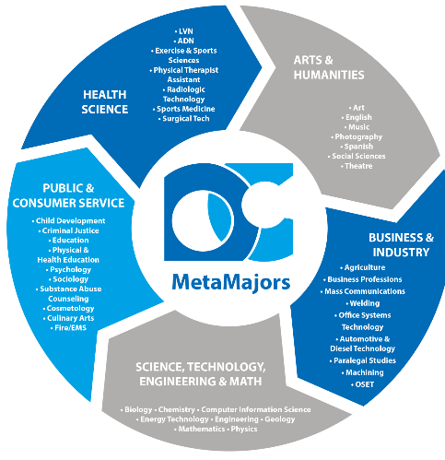
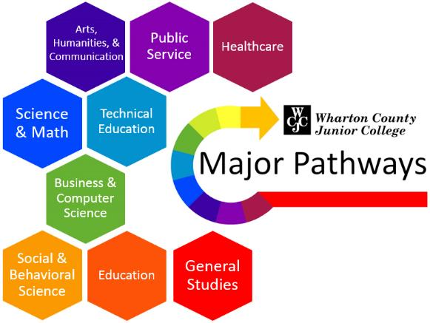

City Colleges of Chicago – Focus Areas http://www.ccc.edu/departments/Pages/transfer/Focus-Areas.aspx
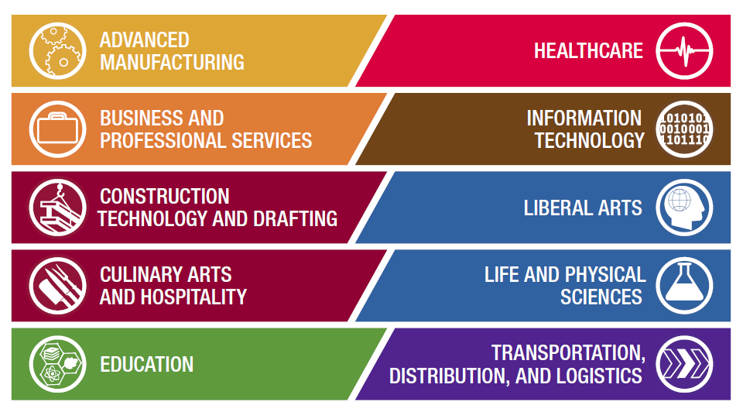
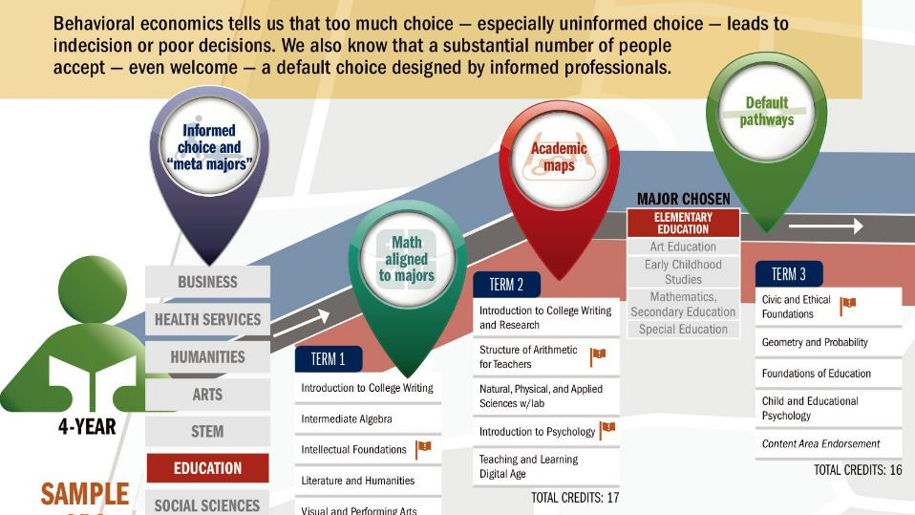
How could evaluating and clustering degrees and certificates benefit your college?

College | Metamajors | Links
Bakersfield College | Agriculture, Nutrition and Culinary Arts  Arts, Humanities and Communication  Business  Education  Health Sciences  Industrial and Transportation Technology  Public Safety Training  Social and Behavioral Sciences  STEM  Personal and Career Exploration | https://www.bakersfieldcollege.edu/academics/pathways
Cabrillo College | Creative Arts & Design  Science Technology, Engineering & Mathematics  Health and Public Service  Entrepreneurship and Business  Global and Human Studies | https://drive.google.com/file/d/1GAO7C2lZrxPNFxZfpoKgI5hUiVL9e5Lw/view
City Colleges of Chicago | Advanced Manufacturing  Business & Professional Services  Construction & Technology  Culinary Arts & Hospitality  Education  Healthcare  Information Technology  Human Sciences  Natural Sciences  Transportation, Distribution and Logistics | http://www.ccc.edu/pages/studentgps/index.html
Kansas Career Fields and Clusters Model | Industrial Manufacturing and Engineering Systems  Health Sciences  Human Resources and Services  Business, Marketing and Management  Environmental and Agricultural Systems  Arts, Communication and Information | https://community.ksde.org/LinkClick.aspx?fileticket=LSmAGUg7czI%3D&tabid=4483
Montgomery College | Math, Physics and Engineering  Education  Business and Management  Chemical and Biological Sciences  Communication and the Arts  Computer and Information Technology  Design and Graphics  Industry and Technical Careers  Society and the World | https://www.montgomerycollege.edu/_documents/academics/meta-majors/metamajorfinal.pdf
Skyline College | Arts, Languages & Communication  Business Entrepreneurship & Management  Science, Technology & Health  Society and Education | https://skylinecollege.edu/metamajors/
Sierra College | Applied Technologies  Business and Innovation  Earth and Environment  Education  Language and Literature  People, Culture and Society  Public Safety, Health and Wellness  Science, Technology, Engineering and Math  Visual and Performing Arts | https://academics.sierracollege.edu/explore-our-academic-programs

